Java Activity 2 (Array)

Ilagan, Ma. Elaiza D.

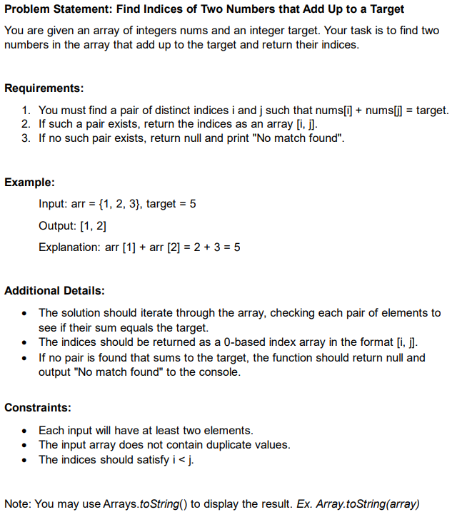

**package** Ilagan_ArrayExercise;

**import** java.util.Arrays;

**public** **class** IlaganArrayExercise {

**public** **static** **int**[] findtheSum(**int**[] num, **int** target) {

**for** (**int** i = 0; i<num.length-1; i++) {

**for** (**int** j = i+1; j < num.length; j++) {

**if** (num[i] + num[j] == target) {

**return** **new** **int**[] {i,j};

}

}

}

System.***out***.println("No match found");

**return** **null**;

}

**public** **static** **void** main(String[]args) {

**int**[] array = {4,5,6};

**int** target = 9;

**int**[] result = *findtheSum*(array, target);

**if** (result != **null**) {

System.***out***.println(Arrays.*toString*(result));

}

// **TODO** Auto-generated constructor stub

}

}